CLIMATE410 Homework 1 Lab Report
Jackson Fenner

Code Design & Methodology

Code Design:

The script was designed to be modular, with wildfire and illness modeled using the same function. Function definitions, testing, and experiments were completed in a single script. Initally, the modeling functions were called separately, but an additional challenge to loop only through time led to the functions being combined. The constant status values for each cell (FORESTED/HEALTHY = 2, ON_FIRE/SICK = 3, BARE/IMMUNE = 1, and DEAD = 0) are shared by both models.

The overall process for simulating the spread in both cases is as follows:
- Create 2D array of initial conditions, either manually or function-generated
- Pass initial conditions into modeling function
- Iterate modeling function until specified time or no spreadable elements left
- Return 3D array of each modeled timestep and time to run

List of Functions Developed:
- create_inital_conditions:
This returns a 2D numpy array of a user-specified size, used as the T=0 for either the wildfire or illness model. It generates a probablity matrix and uses boolean masks to determine individual element values.
- initialize_model_array:
This takes a given 2D numpy array and returns an array which has ghost nodes on the edges. Ghost nodes are the immune/bare state. The user can specify a depth to return a 3D array if need-be.
- get_neighbors:
This function takes a given index (i,j) and returns a touple of indicies representing the orthogonal neighbors. The neighbor order is top, right, bottom, left.
- model_spread:
This function runs the illness and wildfire spread models based on initial conditions and spread probablities, and optional number of timesteps. Cell states are abstracted to be ‘spreadable’, ‘immune’, ‘healthy’, or ‘dead’. It returns the model as a 3D Numpy array and the time required to run.
The first step is call initialize_model_array to add ghost nodes to the edge of the given initial conditions. Then, this buffered array is stored as the first value in a list which holds each calculated timestep. The shape of this array is stored for future reference. Next, we move to into a while loop (if no specificed stop) or a for loop (to run to a given stop). The while loop checks to see if there is a spreadable element in the current timestep. The logic within both loops are identical.
First, we create a random probablity matrix the same size at the current timestep. Then, we flatten the current timestep array and probability matrix row-wise. We create two masks from the timestep vector: one noting spreadable cells and one for healthy cells. Next, we create a vector of indices where spreadable cells occur. Using that index vector, we make a new list of indexes of what would be the orthogonal neighbors in the original matrix. This is be adding/subtracting 1 from the index for the left/right cells, and then adding/subtracting the number of columns (y-dimension) for the top/bottom neighbors. After this, we create a mask that represents the neighbors who are both healthy and are within the probability threshold in the flattened probability matrix. This mask is used to index the neighbor list, which we then use to index the overall flattened timestep matrix and set those values to spreadable (3). Next, we use the initially spreadable mask with the probability list to create both an immune and dead mask. These are then used to set the initially spready cells to either immune or dead, based on the mortality rate. The flattened matrix is then reshaped to its original size and the appened to the overall model list of timesteps.
After the conditions are met to leave the loops, we change the model list to become a numpy array. Then, we slice that array to remove the ghost nodes. We use the depth of the model array to obtain a time_to_run value. Both the model and time_to_run are returned to the user.

After the functions were defined, each test was completed sequentially in the script. Matplotlib was used to plot model tests (described in next section) and for displaying the results of the experiments.

Testing & Validation

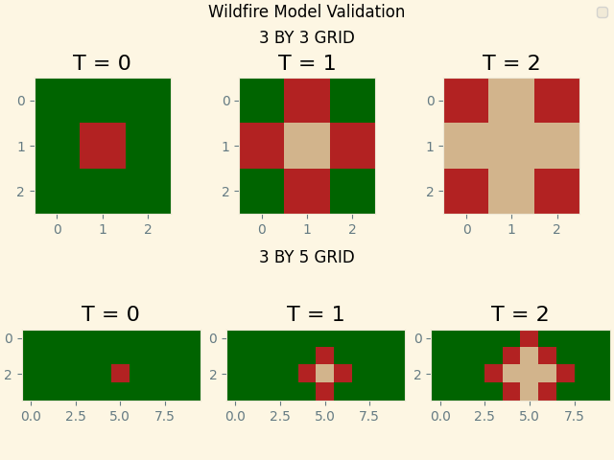
Figure 1. Wildfire Model Spread Validiation, each timestep is labeled above each graph. Colors show forested (green), burning (red), and bare (tan) cells.
The wildfire-specific tests were completed using specifically defined initial conditions, with two test cases: one 3x3 (center on fire), and one 3x5 (almost center on fire) grid. Each began with zero bare spots and 100% fire spread probability. As shown in Figure 1, we can see the fire spread as expected in both cases. The ghost nodes which were inserted during the modeling code are removed properly, and the cell values are correctly executed as well.
Additional testing and validation of the wildfire simulation occurred through print statements to the terminal, as well as individual calls to matplotlib to plot final modeled timesteps.
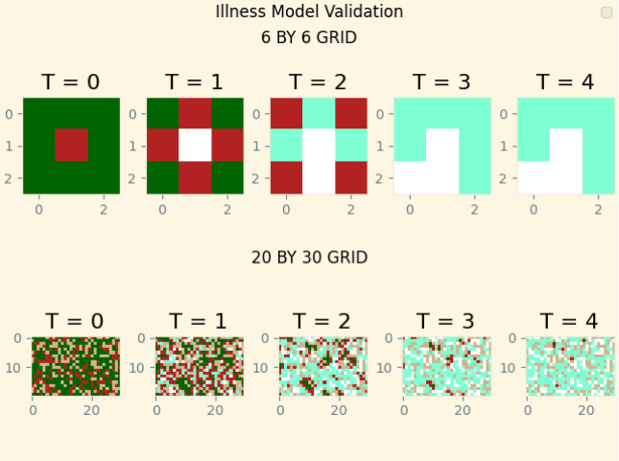
Figure 2. Illness Model Spread Validation. Colors show healthy (green), sick (red), dead (white), immune from sickness (teal), and initially immune (tan).
The Illness spread variation of the model was tested and verifed in a similar way to the wildfire spread variant. In this case, two additional states are shown as seen above in Figure 2: dead (white) and immune after sickness (aquamarine). The aquamarine color is only included as an additional verification method to ensure that intially immune cells (tan) are distinct from cells that recovered after being sick. This is tested by having the modeling function temporarly add a fifth state. Additionally, a larger second test (20x30 grid) was chosen to test the probabilities of death/recovery and initial conditions. These probabilities were set and then calculated from the modeled output (printed to console).

Answers to Questions Posed in Lab:

How do controlled burns reduce likelihood of fires, severity of fires or both?
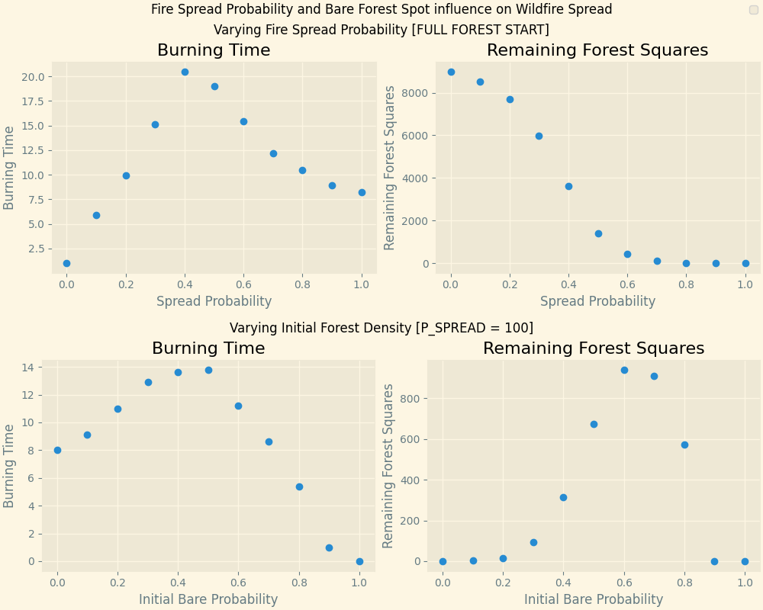
Figure 3. Wildfire Spread Tests showing burning time and remaining forest square response to probabilty of spread and initial bare cell probability. Plotted results represent mean of 10 simulations per trial, each with a 100x100 gridsize.
Overall, it seems controlled burns decrease the severity of fires as well as the likelihood of spread. To test this, we used the wildfire model and varied the intial forest density and firespread probability. Figure 3 (above) shows the results from modeled wildfire output with varying intial controlled burn (bare) cells with 100% spread rate [bottom] and varying wildfire spread probability with zero bare cells [top]. Each trial used a 100x100 grid, with each point representing the average result of 10 simulations. The initial probability a cell would be on fire was 10%. In this case, burning time and remaining forest squares are our proxies for likelihood of fires and severity, respectively.

We see through Figure 3 that there is a ‘sweet spot’ where a certain percent of pre-burned squares both delays fire spread (longer burn time) and maximizes surviving forested cells. There is a balance in the initial forest density- too much means less forest coverage and too little allows fires to spread quickly. As we vary fire spread probability in a non-controlled burned forest, the remaining healthy trees depends heavily on the fire spread probability, with zero remaining healthy trees with any probability greater than 60%. Additionally, burning time peaks just before this probability, higher and fire spreads quickly (no more forested cells) and lower the fire burns out relatively quickly. In a real forest, the density of healthy-to-prescribed-burned area would affect the fire spread probability (likely lower it), which points to controlled burns working to slow fire spread (lower spread likelihood) and preserve healthy forested area (lower severity).

How does disease mortality rate P_survive and early vaccine rates affect disease spread? What does our simple model tell us about the roles of vaccines in presenting large-scale spread of disease?

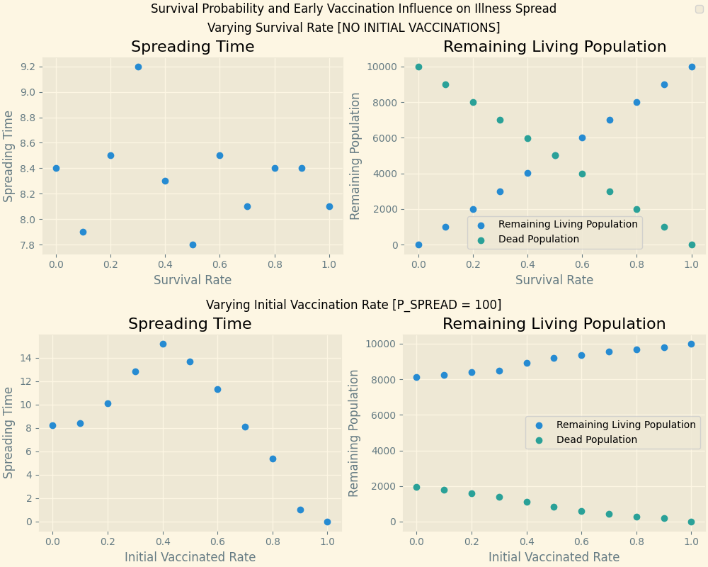
Figure 4. Illness Spread Model showing varying survival rate and initial vaccination rate influence on spreading time and remaining population.
Disease mortatlity rate has less influence on spreading time than early vaccination rate, as seen in Figure 4. Similarly to the last question, the data above represent an average of 10 trials per datapoint, with a 100x100 grid. Initial illness probability was 10%, and the mortality rate for the bottom trial was 20%.
We see that varying survival rate really only affects the remaining population numbers, as the final living and dead population vary directly with the survival rate. The time to spread the illness doesn’t really vary with spreading time in such a direct way. In this simulation, sick members would always spread the illness, which means whether or not an individual died didn’t slow the spread (if they died and were unable to spread the disease). Increasing initial vaccination rate, however, increased the remaining living population. It also slowed spreading time between 20 and 40%, and then hastened to 100%. This hastening is explained by disease being unable to spread and sort of ‘dying out’.
This model result shows us the incredible importance of vaccination as a large-scale disease control mechanism. Even at 20-40% vaccination rate, disease spread is slowed (which can help hospitals with patient volume), and increased vaccination rate from 40% shows faster large-scale disease lifetime and increased remaining living population.

